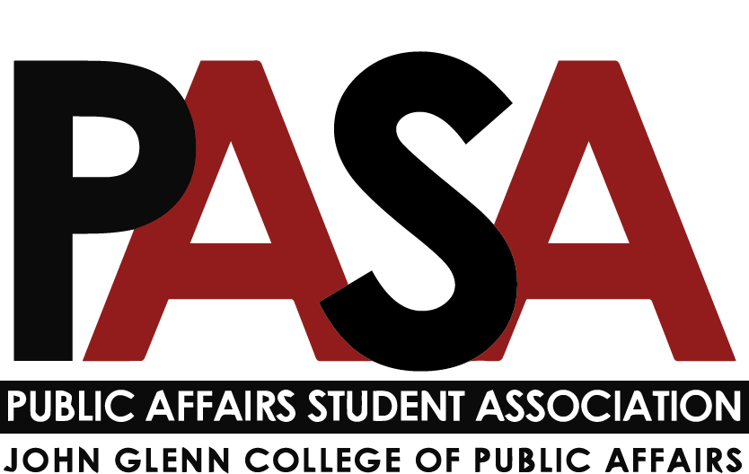
Public Affairs Student Association
Sunday, September 12, 2021
7:00 PM
Zoom Link

- Welcome - Meeting started at 7:04 PM EST
- Open Forum
  - This is the time for anyone who is not part of PASA leadership to speak
  - All PASA Meetings area welcome to attend PASA meetings to stay up to date on what’s going on in PASA and the Glenn College at large.
- E-Board Introductions & Updates
  - President – Casey Rife
    - Introductions
    - PASA Communications
      - GroupMe – Please send me phone numbers
      - Microsoft Teams – Everyone should be added
        - Intro/Tutorial – Carynne
        - Calendar will sync with OSU email calendar
        - Posts will be a place to send message and reply. Make sure notifications are set to your preference
        - Documents are live
        - To-do list tabs can be added to assign tasks throughout the year
      - Using Microsoft Forms and Qualtrics is also free through OSU and helpful for collecting data
    - Committee Updates
      - Glenn committee seats that need appointment
        - Glenn DEI Committee (designated to PASA DEI Committee Chair)
        - Faculty and Staff Committee
        - Technology Committee
        - Wellness and Mental Health Committee
        - Send Casey email with interest in Glen Committees
      - Presidents Meeting (monthly meeting with presidents of Glenn Student Organizations (PAMSO, ICMA, IGNITE, CLC))
        - New Glenn website launching mid-October
          - Events calendar
        - New PASA website
          - Send me a headshot/photo for the site
    - Helpful Glenn Staff to Know
    - Casey will reach out to everyone to talk about their roles and answer any questions.
  - Vice President – Haley Foster
  - Treasurer – Carynne Jarrell
    - Glenn DEI Committee Report
      - Setting goals around the year, including:
        - recruiting diverse students
        - recruiting diverse faculty/staff
        - partnerships with the Kirwan Institute on Race and Ethnicity
    - Budget Committee Report
      - Has completed online training for treasurer
      - Has not meeting yet, as of Sept. 12
  - Secretary – Irene Lewis
    - Committee Report template will be added to Teams (Files > Action Items
    - IG: Highlighting PASA Leadership Team
      - @pasa_osu on Instagram & Twitter
  - External Affairs Coordinator – Samantha Degen
- Committee Chair Updates
  - Note: Reports are due to Secretary no later than 8 p.m. on the Friday before the meeting
  - Service – Tobias Engel
  - Social – Nikolas Merten
  - Diversity, Equity, and Inclusion – n/a
  - Professional Development – n/a
  - Gala – n/a
  - Let Casey know if you know anyone who might be good at or interested in one of the positions above. Rolling applications here.
- Program Representative Updates
  - MPA – Jack Lutat
  - MPA-DC – Paige Shoemaker DeMio
  - MPAL – Joey Eringman
  - Ph.D. – Ken Poland
  - MA – n/a (Let Casey know if you know anyone who might be interested)
- Committee Chair Expectations
  - Update/provide reports to Secretary using template
  - Hold Monthly Meetings with your committee
    - Please add meetings to Teams Calendar to avoid overbooking
  - Request funds well in advance of an event
    - $2000 Budget through Glenn College.
  - Event planning
    - Work with my committee to plan 1-2 events for PASA each semester
  - Work with my committee to attend PASA events and other events within the Glenn College (PAMSO, ICMA, IGNITE, CLC)
  - Plan events for an upcoming month about 3 weeks in advance
  - Meet with committee once per month
- Establishing Committees
  - Committee member interest form will go out soon
  - Recruit friends to join your committee
  - They do not have to attend our monthly meeting
- Program Representative Expectations
  - Communicate with your constituents/colleagues
  - Note any questions/needs/concerns from members of your program
  - Attend PASA events and other events within the Glenn College (PAMSO, ICMA, IGNITE, CLC)
- Breakout Rooms/Mentors
  - Discuss any goals you have for your position!
  - Room 1:
    - President: Casey
    - Vice President: Haley
    - External Affairs Coordinator: Sam
    - MPA-DC: Paige
    - MPAL: Joey
  - Room 2
    - Treasurer: Carynne
    - Secretary: Irene
    - Service: Tobias
    - Social: Nikolas
    - MPA: Jack
    - PhD: Ken
  - Take Aways
    - Many people are taking intentional steps to connect different cohorts and build community while being COVID-conscious
- Questions?
  - Does the budget allocate funds specifically by committee?
    - Budget is not ready formally, but Carynne is willing to answer questions regarding funding for the year.
      - Funds have historically gone mostly to the Gala. Last year, the Gala was virtual and less expensive.
      - Not sure if funds are allocated specifically for each committee
      - We can cross that bridge as people begin planning events

- Meeting adjourned at 7:56 PM EST
- Next Meeting: Sunday, October 3rd at 7pm
- Reminders: Please send Casey (419-619-5199 or rife.307) your phone # for GroupMe and a photo for our website!

