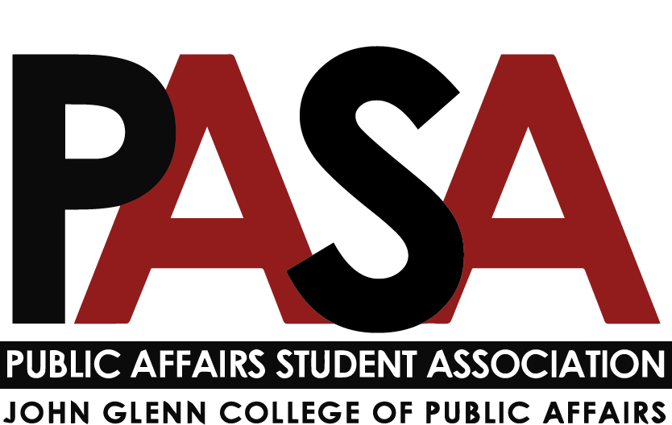
Public Affairs Student Association
Sunday, October 3, 2021
7:00 PM
Zoom Link

Welcome

Open Forum
- This is the time for anyone who is not part of PASA leadership to speak

E-Board Update
- President - Casey Rife
  - President’s Meeting
    - To make room reservations in Page Hall, contact Chris Adams or Elaine
      - Big gate to 1st floor should be open after 5 now, miscommunication with building staff
    - Upcoming Glenn College Events
      - Glenn College Nike BSN Shop will be open 10/4-10/11
      - Versiti Blood Drive on October 12th in Page. Follow this link to schedule.
      - October 12 - Dialogue: The Affordability of Living in Columbus (Virtual) Click here to register.
      - Poll Worker Training on Oct. 21st at Page Hall
      - Glenn College Leadership Forum
        - Friday, October 29 from 9am-4:30pm
        - Register here: https://web.cvent.com/event/2d08376d-ad58-4645-91bc-bccee03ca491/summary?RefId=Agenda
        - LFSTUDENT21 for free attendance
        - Will be recorded and can be watched up to 90 days after
      - Election Night (Nov. 2nd) Virtual Program w/ Michigan on voter access and voting rights, more info soon
    - New Glenn College Website!
      - Will launch on Oct. 13th
      - Reach out to student services if you have trouble finding anything, some parts are still in progress
    - Homecoming Parade
      - A couple Glenn orgs are participating
    - Leadership Forum: The Podcast
      - New Glenn College podcast
  - Officer Update
    - Will be reaching out to schedule 1:1s to make sure everyone is comfortable in their roles
      - Let me know of any questions or concerns in the meantime!
    - PASA Website
      - Still need headshots from a few people to update our website!
    - Glenn College Committees
      - Technology Committee still needs an MPAL Rep if anyone has recommendations
    - Glenn Graduate Ambassador Program
      - Check out the link in last Blast!
    - Still seeking MA Rep, PD Chair, Gala Chair
- Vice President - Haley Foster
  - Updates
    - Meeting with Dean Brown
      - Casey and I met with Dean Brown about two weeks ago. He offered us whatever support he could and offered to further connect us with alumni for events, especially in this virtual climate.
  - Action Items
    - I am trying to do some exploratory work for the Gala.
      - Will help incoming Gala chair is well prepared.
      - Would also be helpful for the Gala meeting to start meeting now
      - Still need to decide on when to have the Gala: Traditionally in January.
- External Affairs - Samantha Degen
  - Curriculum Committee Updates
- Treasurer - Carynne Jarrell
  - Attending Treasurer Training next week and will be sure to share relevant details with you all
  - Attended the Strategic Planning and Budget Meeting, and excited to serve on the committee!
    - Providing input as the strategic plan is being developed. Please reach out if you have anything that Carynne could raise at these meetings.
  - Let me know if you have any $$ requests or budget line items for later in the year that you would like me to plan for
    - Coca-Cola beverage donation is an option for future events
    - Resource room is available. Open House on October 5 at 5:45 pm at Keith B. Key Center for Student Leadership and Service on the second floor of the Ohio Union.
- Secretary - Irene Lewis
  - Updates
    - Please fill out Social Media Survey
    - Updated Program Rep. Report Template
    - Next PASA Blast - October 18th
    - Fall Interest Survey Results
      - full report to come this week

Committee Updates
- Note: Reports are due to Secretary no later than 7 p.m. on the Friday before the meeting
- Diversity, Equity, and Inclusion report - Kennedy Romeo
- Professional Development report - n/a
- Service report - Tobias Engel
  - Updates:
    - Reached out to the following organizations about connecting Glenn students with service opportunities: Habitat for Humanity, Boys and Girls Club, Village in the Ville, Mid-Ohio Food Collective, The Nature Conservancy, and Columbus Coalition for the Homeless. Once the committee is up and running, we will decide if and how we want to partner with these orgs.
    - Student Activities Consultation: This October, the Student Activities Office agreed to meet with the service committee to discuss service opportunities and a potential professional development-public service workshop.
    - Student Life Office is willing to keep service committee on university wide service events & is willing to put on a retreat
  - Upcoming Events:
    - Shooting for the first, full committee meeting the 2nd week of October.
    - Thanksgiving Food Drive: TDB
    - Homeless Vets Happy Hour: TDB working with Tom Willkie to co-host this event.
  - Action Items:
    - Respond to interest survey
    - Decide exact dates for upcoming events/meetings
    - Gauge interest and activities within committee
  - Questions:
    - Would the social committee be willing to co-host a happy hour around Veterans Day that benefits homeless vets?
    - Any recommendations on service opportunities?
- Social report - Nikolas Merten
  - Updates
    - I’ve contacted people that I want to be on my committee that I know will be helpful.
  - Upcoming Events
    - Planning is underway (see below).
  - Action Items
    - Connect with Tobias for a joint social & service event to be planned for mid-October: finding an organization that we want to raise money for and find a restaurant/fast-food place that will donate 10% of proceeds to the organization. Hopefully, MPA and other graduate student cohorts go there together to socialize. It could be worth including the undergraduate analog of PASA, more people = more money raised.
    - Planning a happy hour and/or bar crawl before the weather gets terrible, not exactly sure when.
    - I want to be mindful of Ally’s Halloween party and not stack social/drinking events too close together.
    - Have an MPA-DC student on my social committee and have them solely responsible for planning a social event/happy hour for you all in DC
    - They can also provide input for Columbus events, but I want them to focus on DC for obvious reasons.
    - Start working on planning a tailgate for November 13th
      - Home football game against Purdue (Game time: TBD)
  - Questions
    - I want to plan several events throughout the 2021-2022 school year (see above for only this semester). In order to adequately plan and allocate funds appropriately and responsibly, I would like PASA to develop a specific budget with allocations to each committee. So where are we with our funds and can we develop a budget?
- Gala report - n/a
Program Representatives Updates
- MPA - Jack Lutat
  - Working on cohort engagement.
  - Idea of advocating for a year paid for, long STATA subscription for MPA students
- MPA-DC report - Paige Shoemaker DeMio
  - Updates
    - Haley and I worked together to create a GroupMe for both first and second year MPA-DC students
    - Introduced myself to all students as their PASA rep
    - Katy Hogan and Carynne both requested a virtual happy hour for 1st and second years
    - Sarah Pol requested I gauge interest/plan a DC trip for 1st years to explore neighborhoods with 2nd years in the Spring
  - Upcoming Events
    - Virtual Happy Hour - TBD
    - Spring DC Trip - TBD
  - Action Items
    - Take poll with MPA-DC students to determine time, date, and format for virtual happy hour
    - Gauge interest for DC trip in Spring
- MPAL report - Joey Eringman
  - Questions
    - MPAL demographics
      - Most are working professionals, so low engagement around Glenn and community programming.
      - Working on ideas around how professors can better structure online classes to accommodate MPAL students
      - Maybe using a Facebook group to engage
    - Are there any updates or information on the Capstone for MPAL?
      - Reaching out to MPAL academic advisor.
    - Nonprofit classes not fully online?
- Ph.D. report - Ken Poland
- MA report - n/a (Let Casey know if you know anyone who might be interested)
- CGS Update - Nicholas Klein (Glenn representative)
  - Senator elected out of CFAES
  - Ad hoc committee created to ensure that policies are created to facilitate online accessible online
  - Standard for Emergency payment is trying be determined. The only requirement is that you have a FAFSA on file.
  - Glenn CGS Representatives:
    - Nicholas Klein: klein.436@buckeyemail.osu.edu
    - Caroline Fitzpatrick: fitzpatrick.271@buckeyemail.osu.edu
    - Benjamin McKinley: mckinley.255@buckeyemail.osu.edu

- Questions

