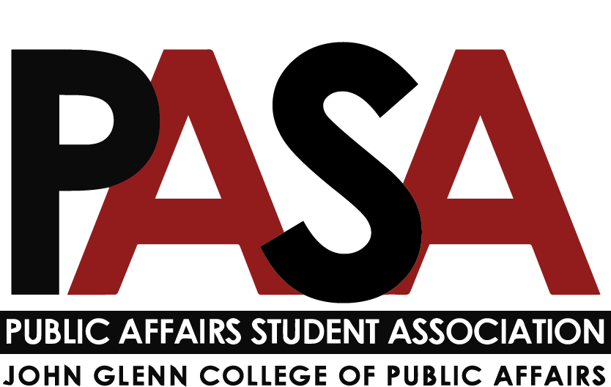
Public Affairs Student Association
Sunday, November 7, 2021
7:00 PM
Zoom Link

Welcome

Open Forum
- This is the time for anyone who is not part of PASA leadership to speak
- Ben McKinley (.255), CGS rep for the Glenn College introduced himself.
  - Advocacy 101 Class in Thompson Library on November 15

E-Board Update
- President - Casey Rife
- President’s Meeting
  - Upcoming Glenn College Events
    - November 9 - Dialogue: New Leadership for Columbus Police (Virtual)
12 - 1 p.m. Register for Dialogue.
    - November 15 – Congressional Conversation with Congressman Troy Balderson (Virtual)
12:10-1:10 p.m. Register for Congressional Conversations.
    - November 15 – PAMSO Allyship Event (Page Hall, Room #130 - LEC)
6:30-7:30 p.m.
    - November 17 - Dinner for Democracy (Virtual)
7:30 p.m.
      - OSU and Michigan (and other Big10 Policy Schools) collaborating on Voter Access
      - Gift cards to first 50 students to buy dinner
      - Presentation and breakout rooms
        - ***graduate student facilitators needed**
        - Let Casey know if you’re interested in helping!
  - New Glenn College Website is now live!
    - Let student services know if you’re having trouble finding anything
- Officer Update
  - 1:1s have been completed!
  - Glenn Graduate Ambassador Program
  - Glenn College Alumni Society’s Alumni Engagement Committee will be planning a virtual holiday wine tasting event that we will all be invited to! More info TBD
  - Gala Info
    - PASA Gala will be February 25th
    - On the MPA student visit day
    - In the process of reserving a space
    - Cash bar, food, keynote speaker, raising money for a philanthropic cause
    - Early planning process, let Haley or Casey know if you’re interested in helping out to plan the Gala!
- Vice President - Haley Foster
  - Gala
    - Casey and I met to discuss the Gala and how we are going to approach planning it.
    - We are shooting for February 25, 2022, because that is the visit day for potential incoming Glenn grad students.
      - We may be meeting with Chris and Lindsey to talk this out a bit more.
    - Thoughts?
- External Affairs - Samantha Degen
  - Committee Updates
    - Graduate Studies Committee: reach out to Sam if you
  - Any ideas for events, feel free to reach out!
- Treasurer - Carynne Jarrell
  - I attended the Treasurer training with Casey in October.
    - Good training for anyone looking to hold a PASA Executive Board position
  - Decided to hold part of our Glenn Budget for programs before the gala, but have not received any requests yet from anyone.
  - Made a video about budget which is on teams and GroupMe that I hope can be a reference if people have questions
  - I'm always open to meeting or attending a committee meeting.
- Secretary - Irene Lewis
  - Updates
    - Social Media
    - Reports sent Friday at 7 pm, text me if you have any concerns (225-270-4823)
    - Next PASA Blast - November 15th (tentatively. Nov. 17 at the latest)
      - Please send any information you want in
    - If anybody needs any specific information or help, let me know!

Committee Updates
- Note: Reports are due to Secretary (Lewis.2837) no later than 7 p.m. on the Friday before the meeting
- Diversity, Equity, and Inclusion report - Kennedy Romeo
  - Updates
    - Committee meeting (10/25)
    - Committee meeting set (11/8)
    - College DEI Meeting
  - Upcoming Events
    - Book Club
      - Narrowing down list of books
    - Trainings for students
      - Looking into what is available through tOSU (free) vs. outside individuals/companies ($)
      - Certificates/professional development to be added to resumes
        - Safe Zone, etc.
    - Information on pronouns
      - Potentially a small workshop/handouts
        - Buttons and brochures
  - Action Items
    - Finalize book list (11/8) and gauge interest
      - Make flyers/set meeting time
    - Speak to Kirwan Institute
    - Price out buttons
  - Questions
    - None
- Professional Development report - n/a
- Service report - Tobias Engel
  - Updates:
    - Veterans Day/ Homeless Veterans Happy Hour (Friday Nov 12th): We agreed on a $10 dollar entry fee, and funds will go towards the Central Ohio Homeless Veterans Stand Down. The goal is to send out an invite/flyer by the end of this week.
    - Thanksgiving Food Drive (Nov 15th- 19th): Tentatively, we are planning on a weeklong food drive where each cohort competes to raise the largest amount of food items. Probably will keep collection bins at the Glenn Help Desk, and Buckeye Food Pantry will be the service partner. It has been past tradition to have a social after the food is delivered, we will keep it simple but let me know if you have any recommendations. Planning to announce at the next PASA meeting and sending the details by next Mon (a week in advance).
      - Potential social even following food drive drop off
    - Volunteer Blast: We are hoping to start a bi-monthly volunteer blast with different service opportunities. If you have any ideas, events, or comments please reach out.
    - If you are interested in helping with the Thanksgiving Food Drive or the Volunteer Blast, please shoot me an email.
- Social report - Nikolas Merten
  - Thanks to everyone who attend the Happy Hour at Julep!
  - Planning on another social event after Thanksgiving holiday
- Gala report - n/a
Program Representatives Updates
- MPA - Jack Lutat
  - looking to engage with Gala committee
  - looking to engage cohort via GroupMe or slack to foster cohort communications
- MPA-DC report - Paige Shoemaker DeMio
  - Updates
    - Many students are interested in planning a trip to DC for the Spring
    - Have been working with first-years to brainstorm ideas for virtual happy hour and what they think will be the best format
  - Upcoming Events
    - Virtual Happy Hour - TBD
    - Spring DC Trip - TBD
  - Action Items
    - Finalize date and time for virtual happy hour
- MPAL report - Joey Eringman
  - Working on an issue with a non-communicative professor with the dean of curriculum and MPAL advisor
  - Technology committee meeting: transition from Buckeye Box to One Drive
    - questions about how researchers in and outside the university will be able to collaborate on materials
- Ph.D. report - Ken Poland
- MA report - n/a (Let Casey know if you know anyone who might be interested)
- CGS Update
  - Glenn CGS Representatives:
    - Nicholas Klein: klein.436@buckeyemail.osu.edu
    - Caroline Fitzpatrick: fitzpatrick.271@buckeyemail.osu.edu
    - Benjamin McKinley: mckinley.255@buckeyemail.osu.edu
- Questions

