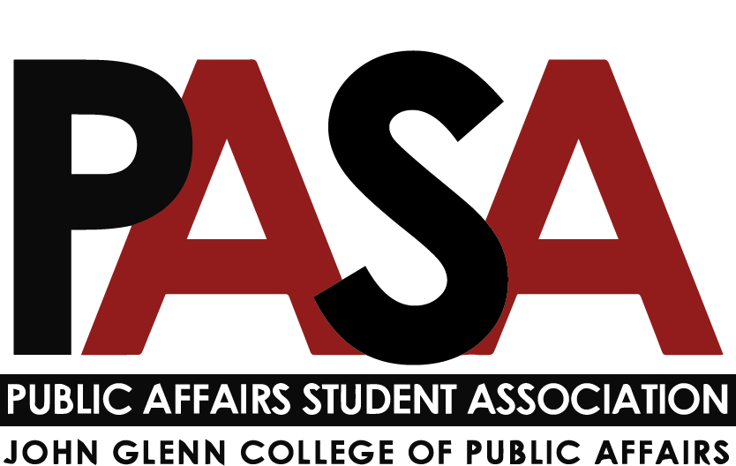
Public Affairs Student Association
Sunday, December 5, 2021
7:00 PM
Zoom Link

Welcome

Open Forum
- This is the time for anyone who is not part of PASA leadership to speak

E-Board Update
- President - Casey Rife
- Officer Update
  - Alumni Society Wine Tasting event this week
  - PASA Gala will be **MARCH 25th
    - Cartoon Room in the Union
    - Haley will reach out to schedule a committee meeting soon
    - Start thinking about any philanthropic organizations you might be interested in donating to or hearing a keynote from
  - I am here if anyone needs help or guidance with their committee or anything!
  - New PASA members - Please let me know your shirt sizes and I will get a PASA shirt reserved for you to pick up from Glenn 110!
    - Cash bar, food, keynote speaker, raising money for a philanthropic cause
    - Early planning process, let Haley or Casey know if you’re interested in helping out to plan the Gala!
  - Start thinking about transition material for next semester. These are documents similar to what you received at the beginning of the year that will help those who are in your position next academic year.
  - Think about any revision you’d like to the Constitution. We will discuss this at our first Spring meeting on January 9, 2022
- Vice President - Haley Foster
  - Gala
    - Casey and I met to discuss the Gala and how we are going to approach planning it.
    - We are shooting for March 25, 2022
      - We may be meeting with Chris and Lindsey to talk this out a bit more.
    - Thoughts?
    - Potential Location: Cartoon Room in the Ohio Union.
- External Affairs - Samantha Degen
  - Will be attending first faculty and staff meeting soon.
- Treasurer - Carynne Jarrell
  - Attended Service Committee meeting. Open to attending other committees as needed, espeically if you will be discussing something that may beed funding.
  - Please aim to send me funding requests at least a week in advanced.
- Secretary - Irene Lewis
  - Updates
    - Social Media
    - PASA Blast Updates: Will update schedule and platform to send blast
    - Open to support where needed

Committee Updates
- Note: Reports are due to Secretary (Lewis.2837) no later than 7 p.m. on the Friday before the meeting
- Diversity, Equity, and Inclusion report - Kennedy Romeo
- Updates
  - Committee meeting (11/8)
    - Next meeting (tbd, pending finals)
  - College DEI Meeting
- Upcoming Events
  - Book Club
    - List of books chosen
    - Survey created
    - Need to determine appropriate send-out date
  - Trainings for students
    - Still looking into what is available through tOSU (free) vs. outside individuals/companies ($)
    - Certificates/professional development to be added to resumes
      - Safe Zone, etc.
  - Information on pronouns
    - Small workshop/handouts
    - Buttons and brochures
    - Design ideas in process
    - Using Casey’s button maker
- Action Items
  - Send out book club interest survey
- Professional Development report - n/a
- Service report - Tobias Engel
- Past Events: The food drive had the largest return of any on-campus food drive that donated to the Buckeye Food Pantry (over 180 items). Our happy hour raised $40 for the Central Ohio Veteran Stand Down.
- Service Opportunity Blast: Next semester, we are looking to get regular messaging with service opportunities, contact me if you would like to help out or have ideas.
- Professional Panel (Date TBD): Next semester we are hoping to host a professional development panel. Committee members are leaning towards a "nonprofit management" theme, but if anyone has ideas please feel free to share.
- If you are looking to connect with local service opportunities before the holidays there is a link below.
- Social report - Nikolas Merten
- Gala report - n/a
Program Representatives Updates
- MPA - Jack Lutat
- MPA-DC report - Paige Shoemaker DeMio
- MPAL report - Joey Eringman
  - Updates
    - Good conversations with faculty regarding challenges with online classes
    - Tech Committee Updates
    - Box migration has begun and should be completed
    - Instructors will being experimenting with new immersive software
- Ph.D. report - Ken Poland
- MA report - n/a (Let Casey know if you know anyone who might be interested)
- CGS Update
  - Glenn CGS Representatives:
    - Nicholas Klein: klein.436@buckeyemail.osu.edu
    - Caroline Fitzpatrick: fitzpatrick.271@buckeyemail.osu.edu
    - Benjamin McKinley: mckinley.255@buckeyemail.osu.edu
- Questions

