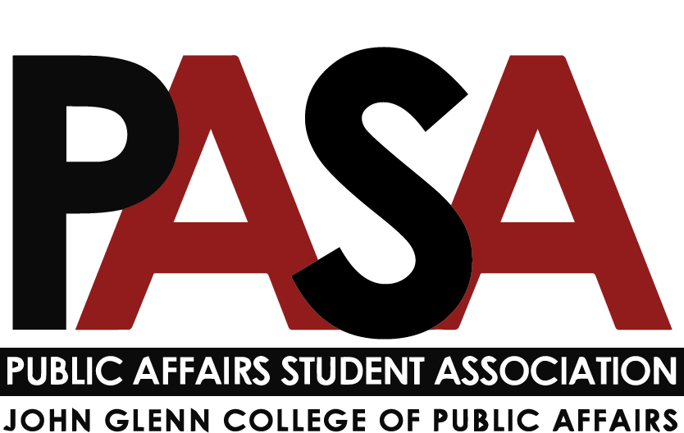
Public Affairs Student Association
Sunday, January 9, 2021
7:00 PM
Zoom Link

Welcome

Open Forum
- This is the time for anyone who is not part of PASA leadership to speak

E-Board Update
- President - Casey Rife
- President’s Meeting
- Upcoming Glenn Events
  - January 16 – Sunday Supper Inspired by Dr. Martin Luther King Jr. (Virtual) 4 – 5:30 p.m.
    - Join us for the second Glenn College MLK Sunday Supper. Inspired by Dr. Martin Luther King Jr.'s vision that people of diverse backgrounds could come together, discuss injustices of the day and create a plan for action, this event is an opportunity to begin new conversations on social change with a diverse group of students, alumni, faculty and staff. Featured Dialogue: Allyship, presented by guest speaker, Z Tenney, Diversity, Equity & Inclusion Officer for the College of Pharmacy. Register for Sunday Supper
    - If you are interested in leading a breakout room, please contact Casey
  - February 8 - Dialogue: Gas to Groceries – Why Are We Paying So Much? (Virtual) 12 - 1 p.m. — Registration opens soon!
- Upcoming Visit Days for admitted MPA students
  - STUDENTS NEEDED https://www.signupgenius.com/go/5080b4ea4a72aa0fd0-mpaadmitted
    - Friday, February 25th (in-person)
      - Student organization panel, 2-2:45pm, at least 1 PASA representative to talk more about PASA and activities they can take part in, the mission of the organization, any other relevant information you’d like to share.
      - Current student panel, 3-3:30pm, Would love at least 2 or 3 students from PASA to talk to current students about being a MPA student, either a 1st or 2nd year MPA is ok. Not really a formal agenda, but a chance for current students to talk to admitted students for AU22.
    - Friday, March 25th (virtual)
      - Current student panel, 1:45-2:15pm. This will be a breakout room for just students to talk - current MPA to admitted MPA students.
    - If you are interested in participating, please contact Casey
- Officer Update
  - PASA Shirts - will make available for pickup in Glenn 110 soon
- Vice President/Gala Updates - Haley Foster
  - Gala Committee asking leadership to help choose 4-5 philanthropic organizations that the Gala will donate to this year (possible organizations shared along with meeting minutes)
- External Affairs - Samantha Degen
  - Attended faculty staff meeting on Friday, January 7th
    - OSU is really committed to being in person
    - Working on getting testing to graduate students and DC students
- Treasurer - Carynne Jarrell
  - Supporting planning for Gala
  - Refer to video in teams account if you have any questions about funding
  - Contact Carynne by the next PASA meeting (February 6ht) if you will be requesting programming funds
  - Glenn College Strategic Planning and Budgeting Committee will eventually have an open meeting this semester to get community input.
- Secretary - Irene Lewis
  - Updates
    - Social Media
    - PASA Blast Updates: Will update schedule and platform to send blast
      - Goal is to send by Monday, January 17
      - Will send spring student availability survey in January Blast
    - Open to support where needed

Committee Updates
- Note: Reports are due to Secretary (Lewis.2837) no later than 7 p.m. on the Friday before the meeting
- Diversity, Equity, and Inclusion report - Kennedy Romeo
  - Will be having first semester meeting during second or third week of semester
  - Potential books and survey created for Book Club.
    - Deciding if this will also be open to undergrads
- Service report - Tobias Engel
  - Will be having first semester meeting during second or third week of semester
  - Service Opportunity Blast: This semester, we are looking to get regular messaging with service opportunities, contact me if you would like to help out or have ideas.
  - Professional Panel (Date TBD): This semester we are hoping to host a professional development panel. Committee members are leaning towards a "nonprofit management" theme, but if anyone has ideas please feel free to share.
  - Central Ohio Veterans Stand Down was excited to receive Happy Hour Donations
- Social report - Nikolas Merten
  - setting up committee meeting for next week.

Program Representatives Updates
- MPA - Jack Lutat
  - Will engage with Gala committee
  - Will be engaging more in this semester
- MPA-DC report - Paige Shoemaker DeMio
  - Working to plan a MPA-DC Happy Hour
  - Planning a trip for first years to visit DC
- MPAL report - Joey Eringman
- Ph.D. report - Ken Poland
- CGS Update
  - Glenn CGS Representatives:
    - Nicholas Klein: klein.436@buckeyemail.osu.edu
    - Caroline Fitzpatrick: fitzpatrick.271@buckeyemail.osu.edu
    - Benjamin McKinley: mckinley.255@buckeyemail.osu.edu

- Updates:
  - Teams Folder > Calendar 21-22
  - Please use to plan events for the semester so that events do not overlap

- Open Forum: Starting classes with increase in COVID cases
  - Continue to wear masks and practice sound hygiene
  - MPA-DC will be having all virtual classes for the month of January
  - Policies from Faculty & Staff Meeting
    - No eating & drinking in classes. Wear your mask between consumption
    - No testing required for graduate students because of low transmission rates in classrooms
    - No about mask specifications
    - Professors are not required to accommodate via Zoom if a student has COVID. Professors are given discretion
    - If something is submitted through student accessibility, a professor is not required to immediately accommodate
    - Professors are encouraged host in person classes as much as possible
  - Question: What are the requirements for quarantine if a student tests positive?
    - OSU Med Center is following updated CDC guidelines on quarantine
  - Consider doing events virtually for the time being.
    - If we do need to pivot to virtual, we will prepare to do so closer to March 25th.

- Questions

